Assignment given on 7th of October

1. Create a table named person with fields id, name, city, age, email, country using the following constraints.

i) The field id should be a primary key

ii) Name field cannot be null

iii) city field cannot be null and for default value use “Delhi”

iv) Age should be greater than 18

v) email should be unique and cannot be null

vi) country field cannot be null and for default use “India”

1. Create a stored procedure named “mytable” and store the query that you used above to create a table “person”.
2. Employee table

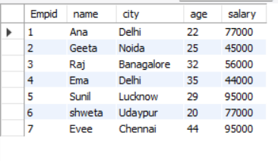

From the above table write a SQL query to

i) Find the highest salary of an employee

ii) Find the third highest salary of an employee

iii) Find the fourth minimum salary of an employee

1. Employee Table



Department Table

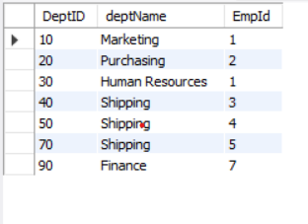

From the above table solve the following

i) Write a query to display the name of the employee who works in the shipping department

ii) Write a query to display the names of the employees who are not in the shipping department.

iii) Write a query to display the name of a department having employees with a salary less than 50000.

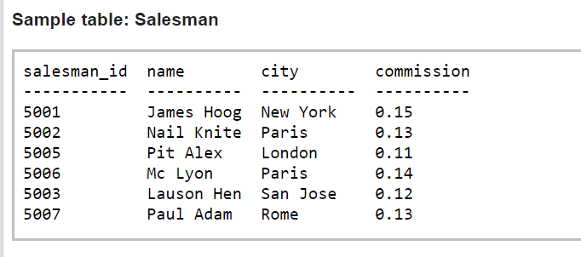

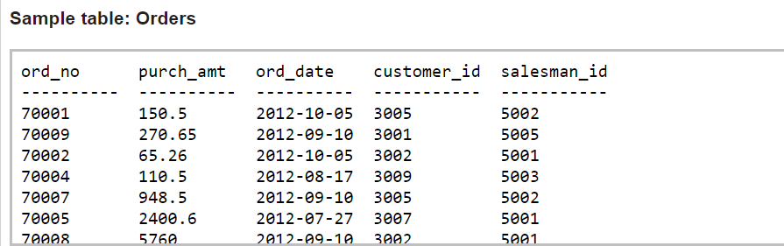

i) From the above tables, write a SQL query to find all the orders issued by the salesman 'Lauson Hen'. Return ord_no, purch_amt, ord_date, customer_id and salesman_id.

ii) From the above tables write a SQL query to find all orders generated by London-based salespeople. Return ord_no, purch_amt, ord_date, customer_id, salesman_id.

iii) From the following tables, write a SQL query to find all the orders generated in New York city. Return ord_no, purch_amt, ord_date, customer_id and salesman_id.

**You can also go through the link given below and practice SQL**

[**https://www.sql-practice.com/**](https://www.sql-practice.com/)